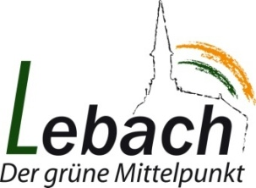

Dear pupils, dear parents,
Everything is different to normal at the moment. Schools are closed although the school holidays have not started yet. It is not possible to attend events, meet up with friends or go to clubs. Everyone is studying at home. The ways in which you can get in touch with teachers, or ask questions if you don’t understand something, are unusual and sometimes even difficult.
In situations like this, being able to talk to someone and to share your worries and concerns in confidence can be helpful. The following contacts continue to be available to you, our pupils, as well as your parents:

School workers (or social workers) at our school:
Sigrun, Meiser
Mobil: 0160 97220091
Tel.: 06831/7641355
Sigrun.meiser@lvsaarland.awo.org

Nummer gegen Kummer (Kinder und Jugendtelefon: support helpline for children and adolescents):
- Free of charge - the call is not listed on the telephone bill
- Anonymous - you do not have to give your name or any other details
Tel.: 116 111
Mon – Sat: 2pm to 8pm
Chat: www.nummergegenkummer.de/kinder-und-jugendtelefon.html
Elterntelefon: support helpline for parents (free of charge and anonymous from mobiles and landlines)
Tel.: 0800 1110550
Mon – Fri: 9am to 11am, and Tue + Thur: 5pm to 7pm
Information can be found here: www.nummergegenkummer.de/elterntelefon.html
Telefonseelsorge telephone helpline (free of charge and anonymous; available to all)
Tel.: 0800 111 0111 or 0800 1110 222
E-mail/chat: https://online.telefonseelsorge.de

